2 7 2 1 5

0000

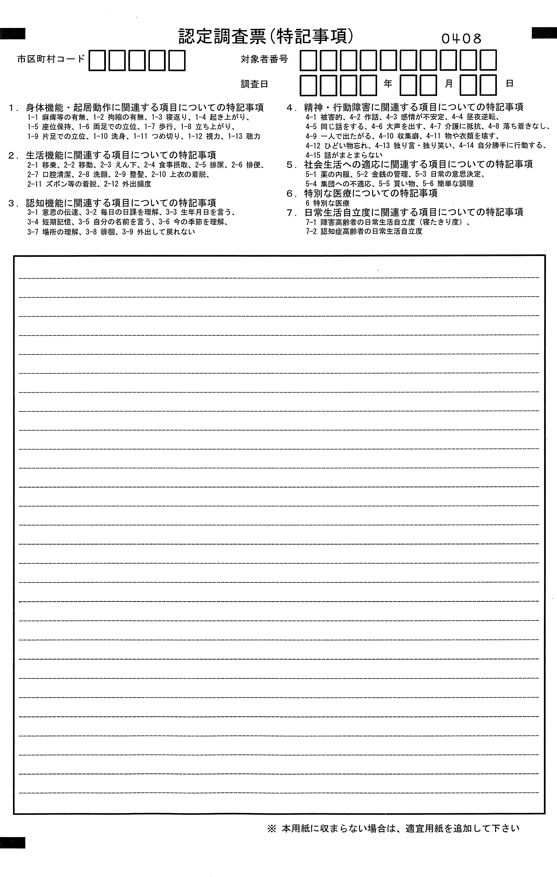

202

|  |  |
| --- | --- |
| 特記コード | 特記内容 |
|  |  |
|  |  |
|  |  |
|  |  |
|  |  |
|  |  |
|  |  |
|  |  |
|  |  |
|  |  |
|  |  |
|  |  |
|  |  |
|  |  |
|  |  |
|  |  |
|  |  |
|  |  |
|  |  |
|  |  |
|  |  |
|  |  |
|  |  |
|  |  |
|  |  |

2 7 2 1 5

0000



202

|  |  |
| --- | --- |
| 特記コード | 特記内容 |
|  |  |
|  |  |
|  |  |
|  |  |
|  |  |
|  |  |
|  |  |
|  |  |
|  |  |
|  |  |
|  |  |
|  |  |
|  |  |
|  |  |
|  |  |
|  |  |
|  |  |
|  |  |
|  |  |
|  |  |
|  |  |
|  |  |
|  |  |
|  |  |
|  |  |

2 7 2 1 5

0000



202

|  |  |
| --- | --- |
| 特記コード | 特記内容 |
|  |  |
|  |  |
|  |  |
|  |  |
|  |  |
|  |  |
|  |  |
|  |  |
|  |  |
|  |  |
|  |  |
|  |  |
|  |  |
|  |  |
|  |  |
|  |  |
|  |  |
|  |  |
|  |  |
|  |  |
|  |  |
|  |  |
|  |  |
|  |  |
|  |  |